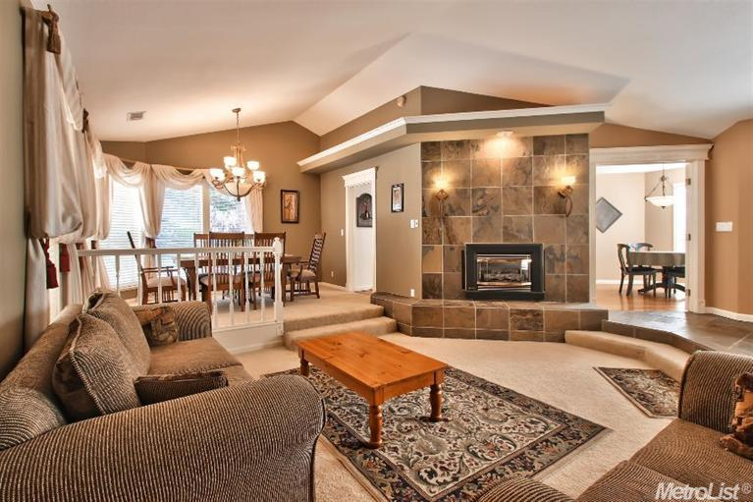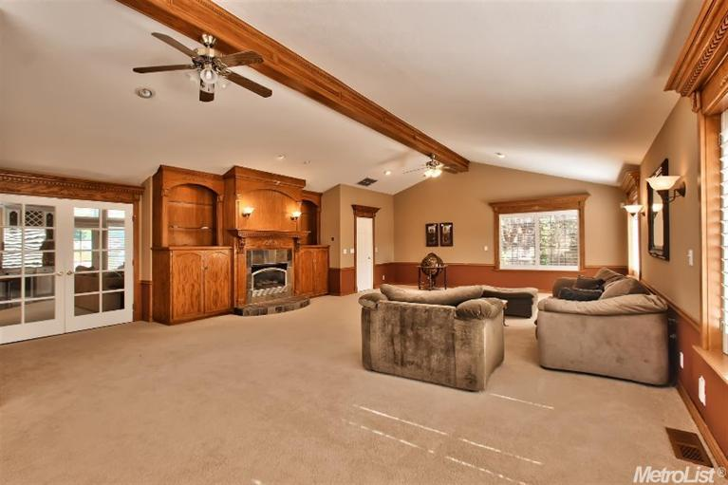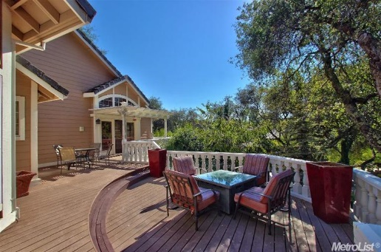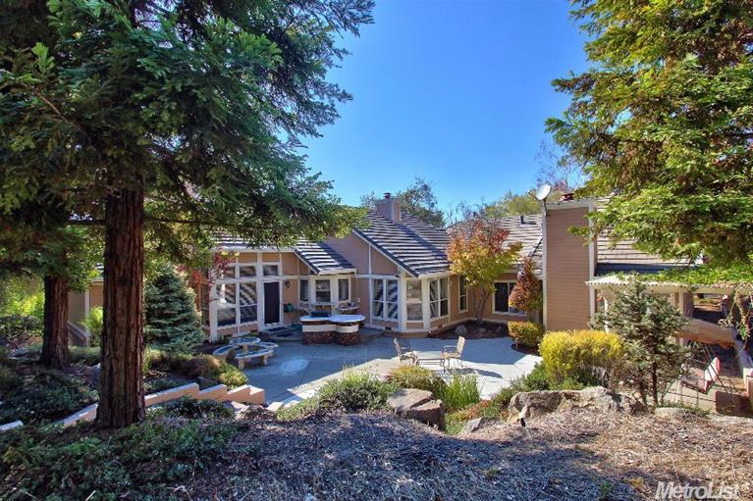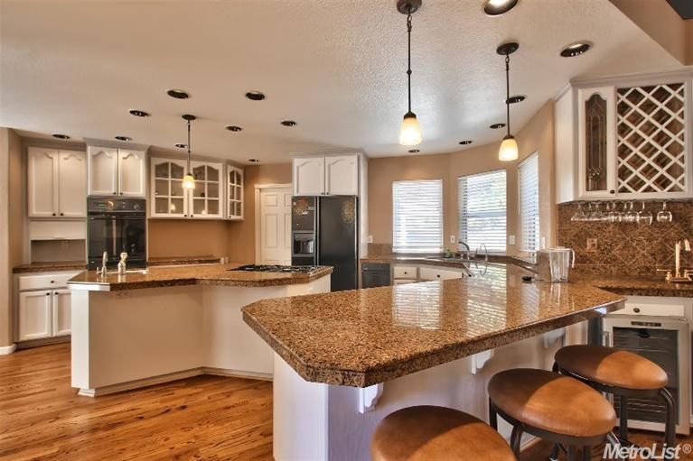

* **3 Bedroom, 3 full Bathrooms, 3,451 sq’ (+/-)**
* **Infinity edge solar heated pool**
* **Spacious Kitchen with open floor plan to family room**
* **Large 1 acre lot with vast valley and downtown Sac. Views**
* **First floor master bedroom with full bath**
* **Attention to detail and finishes abound throughout the home**

#### Etc

* **Etc**
* **Etc**

#### Etc

#### 

**Presented by: Elizabeth Witdoeckt**

w

9119 Eden Oak Circle, Offered at $839,500

**A Very Private Oasis!**

Information deemed reliable, but not guaranteed.

**Direct: 916-365-5696**

**E-mail: john@teamerm.com**

**www.teamerm.com**

**Broker BRE lic #**



8300 Sierra College Blvd. Ste A

Roseville, CA 95661

**9119 Eden Oak Cir. Granite Bay**