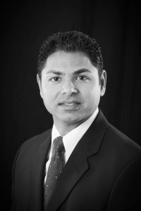

**Let’s Connect!**

**WITH OFFICES IN WALNUT CREEK, PLEASANTON, FREMONT & SACRAMENTO!**

**STEVE BHALLA**

REALTOR® | Sr. Mortgage Loan Officer

Cell | 925.250.6075

Email | stevebhalla@gmail.com

**ANUPAMA BHALLA**

Sr. Mortgage Loan Officer

Cell | 925.260.6888

Email | anupama_bhalla@yahoo.com

The Steve Bhalla Team Proudly Offers Real Estate & Financing Opportunities!

**Lowest Interest RateS in Decades! The Time to Buy OR REFINANCE is Now!**

**ARE YOU CURRENTLY LOOKING TO SELL, PURCHASE OR FINANCE REAL ESTATE?**

**The Steve Bhalla Team** offers vast knowledge and excellent services in every part of the real estate process. We represent buyers and sellers for real estate purchases. We can also assist with your financing needs – whether to purchase or refinance.

**CONTACT US FOR A FREE MARKET ANALYSIS REPORT & A SPECIAL SAVINGS FOR INSPECTIONS OR APPRAISAL!**